Lecture 27, November 30, 2010 (Key Points)

HYDRAULIC-GEOMETRY
Introduction
A large number of dynamic parameters are required to solve network-based mass and momentum conservation equations and predict streamflow hydrographs throughout a network. These parameters represent physical processes of runoff generation in a large number of hillslopes, and of runoff dynamics in a large number of channel links. Most of these parameters cannot be measured, so new theoretical developments are needed to make progress. It is called the challenge of “dynamic parametric complexity” as explained in Lecture 23. In this lecture we will introduce the concept of hydraulic-geometry (Leopold and Maddock 1953), for parameterizing runoff dynamics in a large number of channel links (Mantilla 2007). There is no published literature on parameterizing physical processes of runoff generation (Lecture 14) in a large number of hillslopes. It is an important topic for future research.
27.1 Introduction to Hydraulic-Geometry
Rivers self-adjust their hydraulics (velocity, , friction, , and suspended sediment transport rate, ), and their geometry (depth, , width, , and slope, ), in response to space-time variations in river flows and sediment flows in drainage networks. These six variables are commonly known as the hydraulic-geometric (HG) variables (Leopold, Wolman and Miller, 1964, Ch. 7). Self-adjustment or self-organization is a modern concept that arises in many nonlinear systems. It is also being explored in landscape evolution models that aim to predict various morphometric relations including Horton laws from equations of water and sediment transport (Birnir, Smith and Merchant, 2001). The variations in river flow are determined by the hydrology of drainage basins due to runoff generation from hillslopes and its transport through channel links in a network. Variations in sediment flow are governed by erosion from hillslopes, and erosion and deposition in channel links. Hydraulic-geometric relations were discovered in the 1950s through extensive field observations. Leopold, Wolman and Miller (1964) is a classic reference on hydraulic-geometry.
Leopold and Maddock (1953) first introduced ‘at-a-station HG’ pertaining to temporal variations at a fixed location such as a gauging station, and ‘downstream HG’ pertaining to spatial variations along the reach of a channel. Leopold and Miller (1956) generalized the Horton laws from topologic and geometric variables to HG variables in a network. Key text from the Leopold and Miller (1956) paper is reproduced in Jarvis and Woldenberg (1984).
The basic idea behind the HG relationships is to define a ‘representative stream discharge, ’, and then relate the HG variables to as power laws. The HG relationships are classic results in quantitative fluvial geomorphology that are necessary to model flow of water and sediments in river networks. A great amount of literature pertaining to a physical understanding of HG relationships, and controversies surrounding it, has evolved in the last fifty years. Only the elementary aspects of HG relationships are covered here.
We will first introduce at-a-station HG followed by downstream HG. Leopold and Miller (1956) first showed using empirical arguments that Horton laws exist for mean HG variables in channel networks. However, their arguments have mathematical gaps. To fill these gaps, we will illustrate that statistical self-similarity in drainage areas is required, and how it salvages the Leopold and Miller (1956) reasoning. A unique set of field data from New Zealand on nested basins shows that statistical variability around mean power laws is a very prominent feature. To understand the nature of this variability, Peckham and Gupta (1999) introduced the concept of statistical self-similarity involving full probability distributions. This generalization is based on the key idea that probability distributions of geometric variables rescaled by the means collapse to a common probability distribution. Therefore, the first key step is to understand spatial variability and the Horton laws for the means. A discussion of statistical self-similarity involving full probability distributions is outside the scope of this course.

27.2 At-a-Station Hydraulic Geometry
Most rivers experience a wide range of variation in stream flows in time and space. At a given cross section, the discharge can be expressed as,, where, depth, , width, , and velocity, represent the mean X-sectional values. The wide range of variation in is reflected in these three hydraulic-geometric variables as power laws at a station, given by,

(27.1)

We have adopted the same symbols for exponents and coefficients of the hydraulic-geometric variables as given in Leopold et al. (1964). It follows from the definition, that,

(27.2)

The observed values of average at-a-station hydraulic-geometric exponents in the US are given in Leopold et al. (1964, p. 244). For example, the exponents for the mid-western streams are, , as shown in fig. 27.1. Most of the data is shown for the three variables in Eq. (27.1) because they are relatively easy to measure. Sediment load and slope are more difficult to measure. The friction, is determined from the well-known empirical Manning equation,

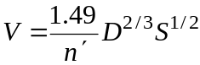 (27.3)

For simplicity, we have replaced the hydraulic radius by channel depth for wide channels. Leopold et al. (1964) have given an excellent discussion of these empirical relationships and some qualitative physical insights about their interdependence.
During the 1970s several attempts were made to predict at-a-station relationships from some basic physical principles based on postulated ‘optimality’. However, a satisfactory physical understanding of empirical at-a-station HG remains open.

Figure 27.1 Changes of width, depth and velocity with discharge at a cross section
(Leopold et al., 1964, p. 216)

27.2 Downstream Hydraulic Geometry
Downstream HG pertains to spatial variations along the reach of a channel. We have represented all the HG relationships given in Leopold et al. (1964, p. 244, Table 7-5). The reference discharge is the bank full flow, that is assumed to correspond to the peak-flow quantile with a recurrence interval of 2.3 years. The empirical downstream HG relationships take a power-law form given by,

(27.4)

The exponents were observed to have characteristic values for different climatic regimes. For example, the exponent for stream widths was found to be pretty stable at b=0.5 for many river basins in the Midwestern US. For the same basins, the depth exponent, f=0.4 and the velocity exponent m=0.1. The exponents for width, depth and velocity add to 1, because . Table 7-5 shows that the exponent for the suspended transport rate is, , and for slopes, . Values of the HG exponents for other regions of the US, for example, the ephemeral steams of the semiarid US are also given in Table 7-5. Leopold et al. (1964, pp. 241-248) have given a nice qualitative physical discussion of these empirical relationships, and their interdependence.
A physical derivation of downstream HG relationships is an important open problem and is an active topic of research. For example, Griffith (2003) used the concept of similitude or scaling in deriving downstream HG relations. Singh et al. (2003) paper on this topic gives a short review of literature, and lists a large number of references pertaining to various theoretical attempts to predict the downstream HG relationships.

27.3 Hydraulic-Geometry in Drainage Networks and Horton Laws
In a classic paper, Leopold and Miller (1956) generalized the applicability of empirical Horton laws from topologic and geometric variables to HG variables (key text from the Leopold and Miller paper is reproduced in Jarvis and Woldenberg, 1984). Their generalization consisted of two steps:

- Observation that a reference discharge defined in terms of annual flood quantiles varies with respect to drainage area as a power law (Lecture 4)
- A Horton law holds for mean drainage areas (Eq. 9.4, Lecture 9).

This generalization was a big conceptual leap in terms of its significance to hydrology and geomorphology. Yet, the Horton laws for HG variables have not recedived much attention in the literature. Perhaps the reasons for this lack of attention may be attributed to a focus on understanding downstream HG relations (Griffith, 2003), and a general misunderstanding of the significance of Horton laws even for topologic and geometric variables. Only recently, the Tokunaga network model has begun to clarify the significance of Horton laws as asymptotic relationships without randomness in it (Lecture 12). This development is likely to provide a greater impetus to developing a physical understanding of Horton laws for the HG variables in river networks.
Our focus here is to explain the Leopold and Miller (1956) arguments, but use some care in defining terms and in carrying out mathematical operations so that we can pin point a major technical difficulty that arises in generalizing the empirical Horton laws to HG variables. Fortunately, this problem can be resolved on the basis of recent developments in network theories that have introduced the concept of statistical self-similarity (SSS) or simple scaling in probability distributions (Lecture 25, Eq. 25.4). SSS enables us to generalize the Horton laws from means to full probability distributions. Therefore, they are referred to as Generalized Horton laws (Peckham and Gupta 1999). SSS in probability distributions has been shown to hold for drainage areas (Veitzer and Gupta 2000).
For the sake of notational simplicity, let us denote a HG variable by X. Let the reference discharge, correspond to annual flood quantile with a return period of 2.3 years, or p=1/2.3. It is very close to the mean peak flow or the bank-full discharge. Let, , denote the mean peak flow given drainage area (recall the concept of conditional mean in regression analysis from Lecture 4). Rewrite Eq. (4.3) (Lecture 4) as,

(27.5)

Here 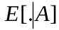 denotes conditional expectation (mean) given A. Let the reference discharge Q in the downstream HG relations in Eq. (27.4) be defined by Eq. (27.5). Then we can rewrite Eq. (27.4), 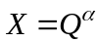 as,
(27.6)
where, is a constant.
Eq. (27.6) holds for any drainage area. In particular, it holds for drainage areas of a complete Strahler streams, 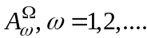. Taking expectation with respect to drainage area in Eq. (27.6), and using the well-known mathematical relationship, 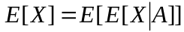 gives,

(27.7)

To obtain a Horton law for the mean HG variables from Eq. (27.7), write,

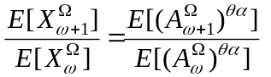 (27.8)

It is a well-known mathematical fact that 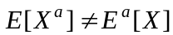 unless , which is not the case here (values of the downstream HG exponents are less than 1). Consequently, one cannot invoke the Horton law of drainage areas and assert from Eq. (27.8) that Horton laws for the mean HG variables holds,

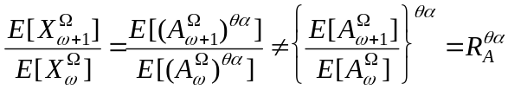 (27.9)

The above mathematical argument shows that the Horton laws for the mean HG variables cannot be asserted on the basis of the two steps that Leopold and Miller (1956) used.
To salvage this situation, we can use the recently discovered SSS in drainage areas (Peckham and Gupta, 1999). SSS states that the probability distributions of random variables, say drainage areas , divided by their means 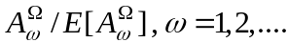collapse to a common probability distribution of a random variable Z, which does not depend on Strahler order. Using Moment Eqs. (25.9a) from Lecture 25 in conjunction with Eq. (27.9) gives,
(27.10)

Thus a generalized Horton law involving SSS in drainage areas salvages Horton laws for mean HG variables that Leopold and Miller (1956) first reported. It also shows that the Horton ratios are related as, (Veitzer and Gupta 2001). A generalization of Horton relationships from topologic and geometric variables to the HG variables was a very big conceptual step in the evolution of river-basin hydro-geomorphology 60 years ago.
27.4 New Field Studies of the HG variables in River Networks
New field investigations in two river basins in New Zealand have been published on HG variability (Ibbit et al., 1998; McKerchar et al., 1998). They are by far the most comprehensive set of field investigations on HG variability in channel networks. These field investigations considered a low-flow discharge over a four-day period as a reference discharge, , which did not change much with time. Therefore, the reference discharge is neither the bank full flow nor a flood quantile with a 2.3-year return period. This is noteworthy, because reference discharge is a physical quantity that must conserve mass. Defining it in terms of quantiles can violate mass conservation (Furey and Gupta, 2000, p. 2686).
A scatter plot of the HG relationships for the Ashley basin, NZ and a fit of regression equation showing power laws is given in Fig. 27.2. It clearly shows that
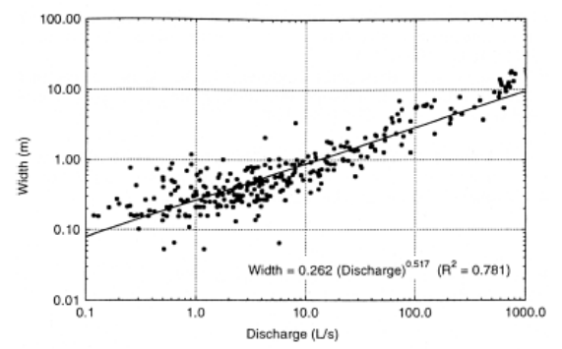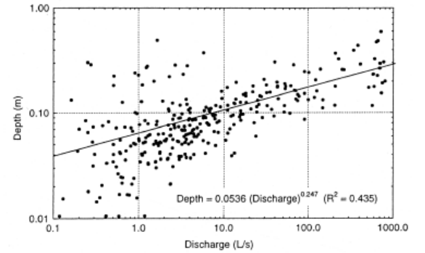
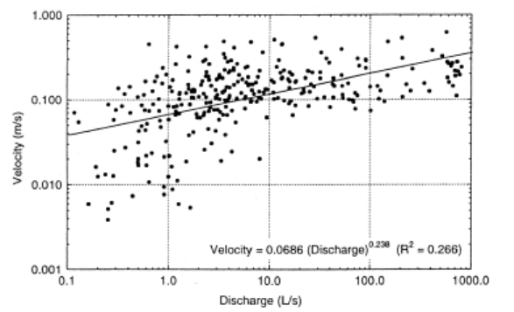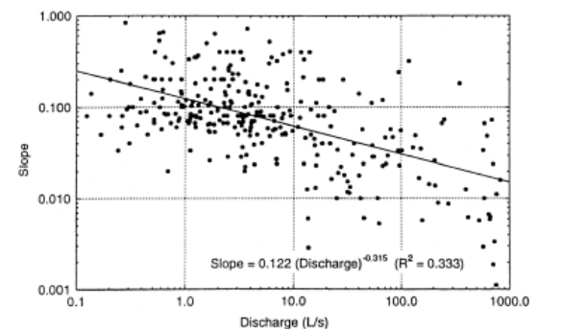
Figure 27.2 Power laws in mean width, depth, velocity and slope, Ashley basin, NZ (Ibbitt et al, 1998)
the mean behavior of HG variables in not sufficient, and understanding statistical fluctuations around the mean is necessary. The concept of SSS as explained above can be explored. It is a topic for future research.

References

Birnir, B., T. R. Smith, and G. E. Merchant. The scaling of fluvial landscapes. Computers and Geosciences, 27: 1189-1216, 2001.

Furey P. and V. K. Gupta. Space–time variability of low stream flows in river networks. Water Resour Res, 36(9): 2679–90, 2000.

Griffiths, G. A. Downstream hydraulic geometry and hydraulic similitude. Water Resour. Res., 39(4), 2003.

Ibbitt, R. P, A. I. McKerchar, and M. J. Duncan. Taieri River data to test channel network and river basin heterogeneity concepts. Water Resou. Res., 34(8): 2085-2088, 1998.

Jarvis, R.S., and M.J. Woldenberg, River networks, Benchmark Papers in Geology, vol. 80, R. S. Jarvis and M. J. Woldenberg (Ed.), 386 pp., Van Nostrand, 1984.

Leopold, L., M. G. Wolman, and J. P. Miller. Fluvial Processes in Geomorphology. Freeman, 1964.

Leopold, L. and T Maddock. The hydraulic-geometry of stream channels and some physiographic implications. USGS Prof. Paper 252: 57pp, 1953.

Mantilla, R. Physical basis of statistical scaling in peak flows for topologically and spatially embedded random self-similar channel networks, PhD Dissertation, University of Colorado, Boulder, CO. USA, 2007.

McKerchar, AI, RP Ibbitt, SLR Brown, and MJ Duncan. Data for Ashley River to test channel network and river basin heterogeneity concepts. Water Resou. Res., 34(1): 139-142, 1998.

Peckham, S. and Gupta V. K., A reformulation of Horton laws for large river networks in terms of statistical self-similarity, Water Resour. Res., 35(9), 2763-2777, 1999.

Singh, V. P. Downstream hydraulic geometry relations: 1. Theoretical development. Water Resources Res., 39(12): 1337, 2003.

Veitzer S. and V. K Gupta. Random self-similar river networks and derivations of generalized Horton laws in terms of statistical simple scaling. Water Resou. Res, 36(4): 1033–48, 2000.

Veitzer, S., and V. K. Gupta, Statistical self-similarity of width function maxima with implications to ﬂoods, Advances in Water Resources, 24, 955–965, 2001.

